# Question 3

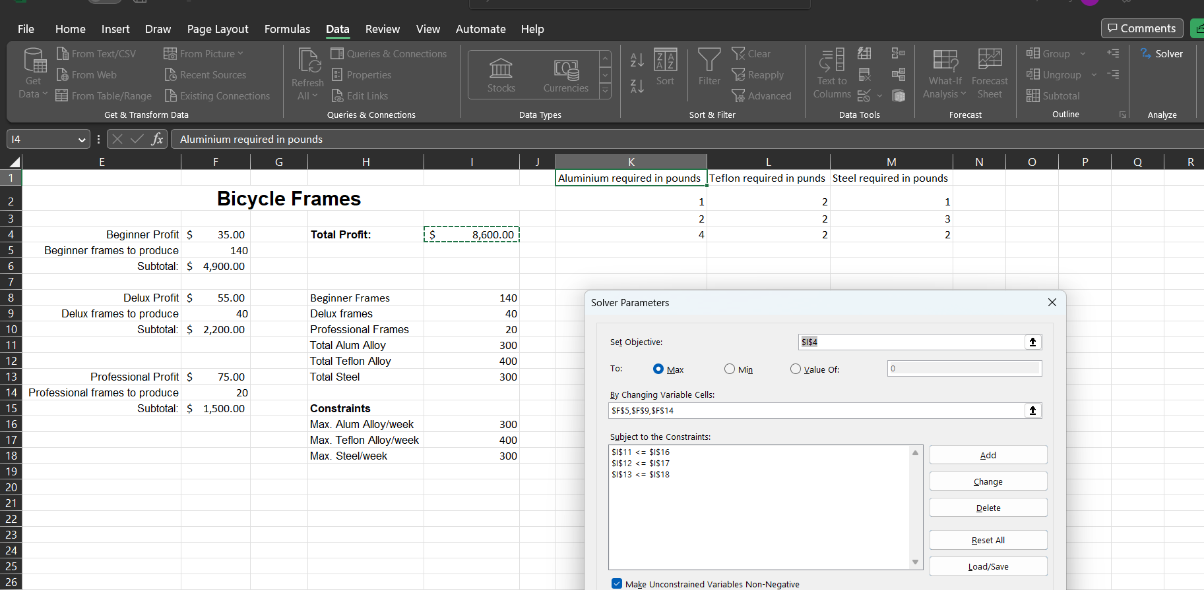

**Solver Z function:**

